**First()**

1. Returns first element of a sequence.
2. It throw an error when There is no element in the result or source is null.
3. you should use it,If more than one element is expected and you want only first element.

**FirstOrDefault()**

1. Returns first element of a sequence, or a default value if no element is found.
2. It throws an error Only if the source is null.
3. you should use it, If more than one element is expected and you want only first element. Also good if result is empty.

We have an UserInfos table, which have some records as shown below. On the basis of this table below I have created example...

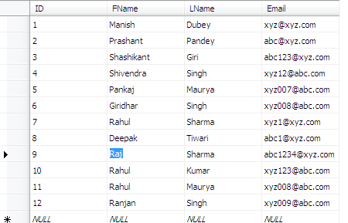

**How to use First()**

var result = dc.UserInfos.First(x => x.ID == 1);

There is only one record where ID== 1. Should return this record  
ID: 1 First Name: Manish Last Name: Dubey Email: xyz@xyz.com

var result = dc.UserInfos.First(x => x.FName == "Rahul");

There are multiple records where FName == "Rahul". First record should be return.  
ID: 10 First Name: Rahul Last Name: Kumar Email: xyz123@abc.com

var result = dc.UserInfos.First(x => x.ID ==13);

There is no record with ID== 13. An error should be occur.  
InvalidOperationException: Sequence contains no elements

**How to Use FirstOrDefault()**

var result = dc.UserInfos.FirstOrDefault(x => x.ID == 1);

There is only one record where ID== 1. Should return this record  
ID: 1 First Name: Manish Last Name: Dubey Email: xyz@xyz.com

var result = dc.UserInfos.FirstOrDefault(x => x.FName == "Rahul");

There are multiple records where FName == "Rahul". First record should be return.  
ID: 10 First Name: Rahul Last Name: Kumar Email: xyz123@abc.com

var result = dc.UserInfos.FirstOrDefault(x => x.ID ==13);

There is no record with ID== 13. An error should be occur.